NAME: ________________________
NUMBER: ________________________
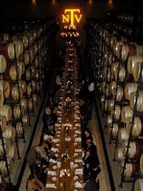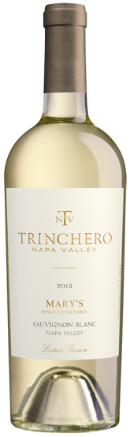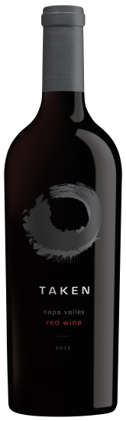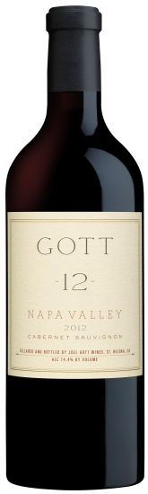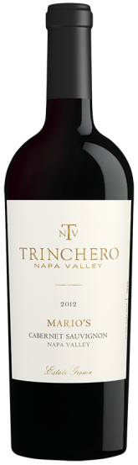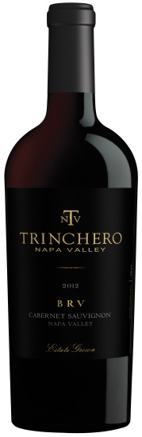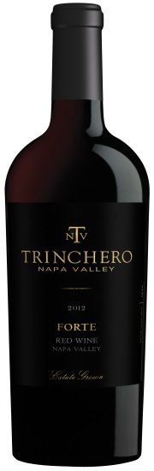

REGULAR SALE BOTTLE
RICE PRICE PURCHASE

2015 TNV MARY’S VINEYARD $24.99 $19.99 ________
SAUVIGNON BLANC

2013 TAKEN NAPA VALLEY $29.99 $24.99 ________
RED BLEND

2012 GOTT NAPA VALLEY $59.99 $49.99 ________
CABERNET SAUVIGNON

2012 TNV MARIO’S VINEYARD $59.99 $44.99 ________
CABERNET SAUVIGNON

2012 TNV FORTE NAPA VALLEY $74.99 $59.99 ________
RED BLEND

2012 TNV BRV NAPA VALLEY $89.99 $64.99 ________
CABERNET SAUVIGNON

